

#### Pandas:



Data scientists use Pandas for its following advantages:



#### DATA STRUCTURE IN PANDAS



Pandas deals with 3 data structure-



We are having only series and data frame in our syllabus.



**Series-**Series is a one-dimensional array like structure with homogeneous data, which can be used to handle and manipulate data. What makes it special is its index attribute, which has incredible functionality and is heavily mutable.



**e.g.-**

| Index | Data |
| --- | --- |
| 0 | 10 |
| 1 | 15 |
| 2 | 18 |
| 3 | 22 |

* We can say that **Series** is a labeled *one-dimensional array which can hold any type of data.*
* Data of **Series** is *always mutable*, means it can be changed.
* But the size of Data of **Series** is *always immutable*, means it cannot be changed.
* **Series** may be considered as a **Data Structure with two arrays** out which **one array** works as *Index (Labels)* and the **second array** works as *original Data.*
* ***Row Labels*** in Series are called *Index*.





* **Where data may be *python sequence (Lists)*, ndarray, scalar value or a python dictionary.**



**Program-**





**Program-**

| **import pandas as pd** | **Output-** |
| --- | --- |
| **import numpy as np arr=np.array(['a','b','c','d']) s=pd.Series(arr,**  **index=['first','second','third','fourth'])** | first a second b third c fourth d |
| **print(s)** |

## Creating a series from Scalar value



To create a series from scalar value, an index must be provided. The scalar value will be repeated as per the length of index.

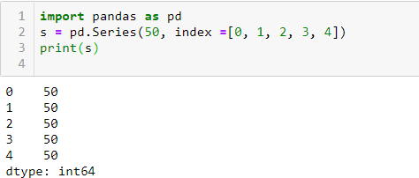

**Creating a series from a Dictionary**

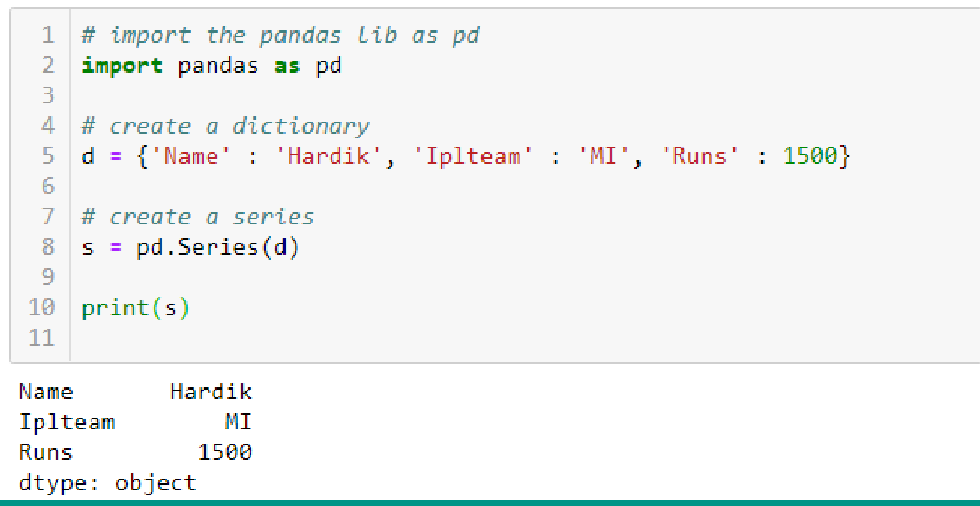

**Mathematical Operations in Series**







## Example-2





**Head and Tail Functions in Series**



head (): It is used to access the first 5 rows of a series. Note :To access first 3 rows we can call series_name.head(3)



tail(): It is used to access the last 5 rows of a series. Note :To access last 4 rows we can call series_name.tail (4)

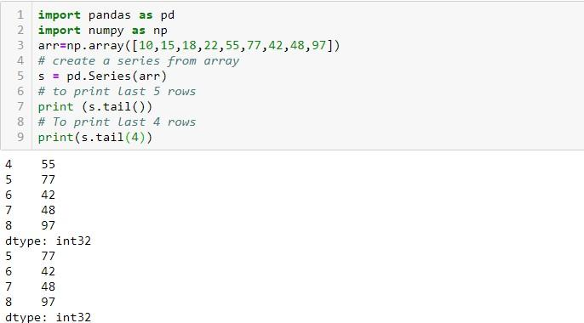

## Selection in Series



Series provides index label loc and ilocand [] to access rows and columns.

1. loc index label :-

Syntax:-series_name.loc[StartRange: StopRange] Example-



1. Selection Using iloc index label :-

Syntax:-series_name.iloc[StartRange : StopRange] Example-

1. Selection Using [] :

Syntax:-series_name[StartRange> : StopRange] or series_name[ index]

Example-



## Indexing in Series



Pandas provide index attribute to get or set the index of entries or values in series.

Example-

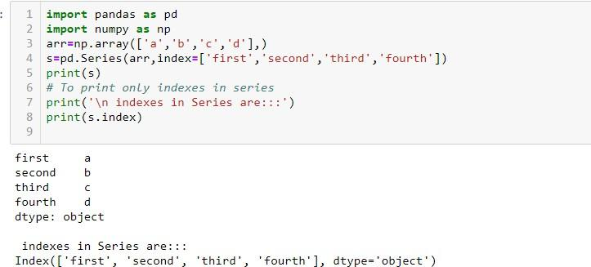

## Slicing in Series



Slicing is a way to retrieve subsets of data from a pandas object. A slice object syntax is –

###### SERIES_NAME [start:end: step]

The segments start representing the first item, end representing the last item, and step representing the increment between each item that you would like.

Example:-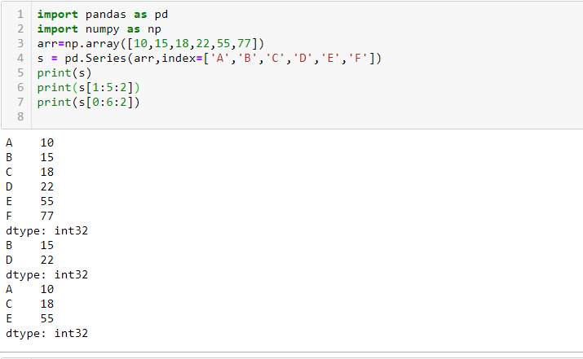



**DATAFRAME**-It is a two-dimensional object that is useful in representing data in the form of rows and columns. It is similar to a spreadsheet or an SQL table. This is the most commonly used pandas object. Once we store the data into the Dataframe, we can perform various operations that are useful in analyzing and understanding the data.

**DATAFRAME STRUCTURE**

| **COLUMNS** | | **PLAYERNAME** | **IPLTEAM** | **BASEPRICEINCR** |
| --- | --- | --- | --- | --- |
|  | | | | |
| 0 |  | ROHIT | MI | 13 |
| 1 | VIRAT | RCB | 17 |
| 2 | HARDIK | MI | 14 |

 

**INDEX DATA**





**A data frame can be created using any of the following-**

1. **Series**
2. **Lists**
3. **Dictionary**
4. **A numpy 2D array**

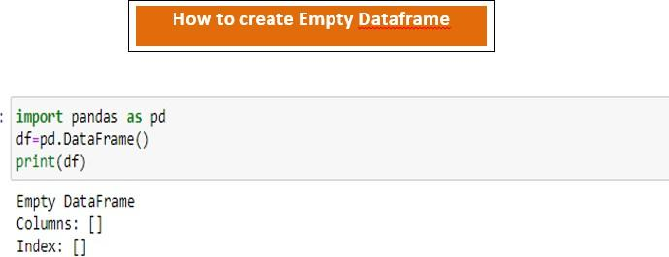



**Program-**



## DataFrame from Dictionary of Series



Example-

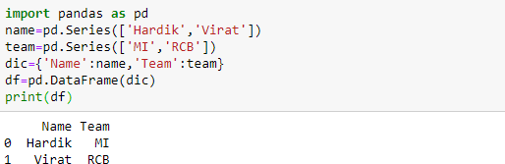

## DataFrame from List of Dictionaries



Example-

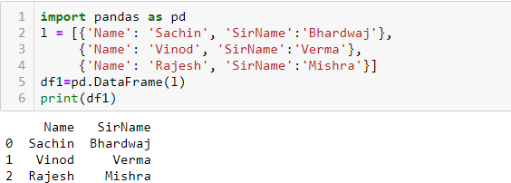

## Iteration on Rows and Columns



If we want to access record or data from a data frame row wise or column wise then iteration is used. Pandas provide 2 functions to perform iterations-

1. iterrows ()
2. iteritems ()

## iterrows()



It is used to access the data row wise. Example-

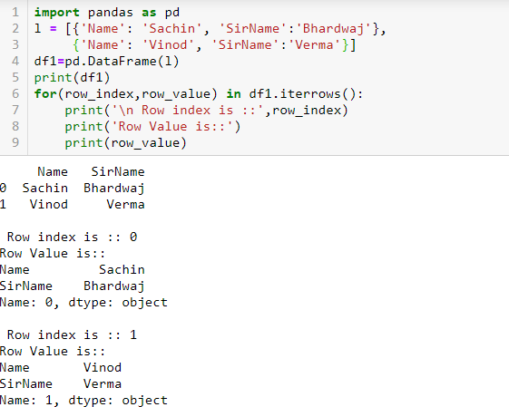

## iteritems()



It is used to access the data column wise. Example-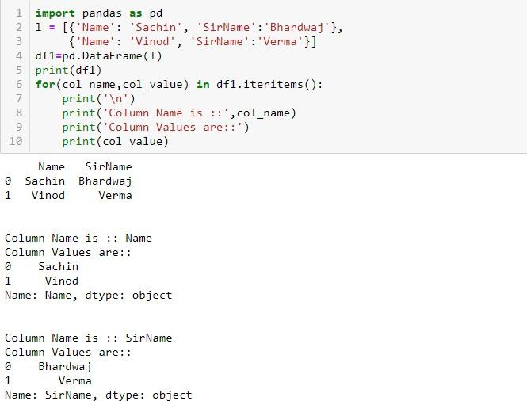

# Select operation in data frame



**To access the column data ,we can mention the column name as subscript.**

**e.g. - df[empid] This can also be done by using df.empid.**

**To access multiple columns we can write as df[ [col1, col2,---] ]**

**Example -**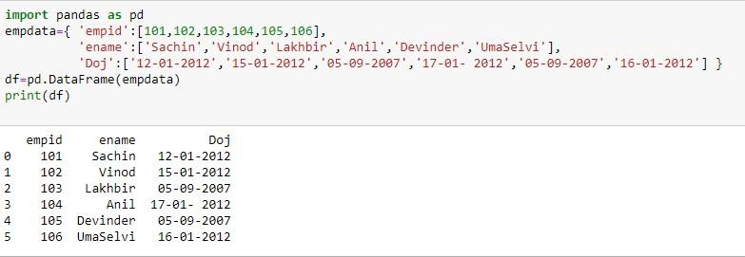



|  | **empid** | **ename** |
| --- | --- | --- |
| **0** | **101** | **Sachin** |
| **1** | **102** | **Vinod** |
| **2** | **103** | **Lakhbir** |
| **3** | **104** | **Anil** |
| **4** | **105** | **Devinder** |
| **5** | **106** | **UmaSelvi** |

# To Add & Rename a column in data frame

| **import pandas as pd**  **s = pd.Series([10,15,18,22]) df=pd.DataFrame(s)**  **df.columns=[‘List1’] To Rename the default column of Data Frame as List1**  **df[‘List2’]=20 To create a new column List2 with all values as 20** | | | | |
| --- | --- | --- | --- | --- |
|  |  | | | |
| **df[‘List3’]=df[‘List1’]+df[‘List2’]** | **Output-** | | | |
| **Add Column1 and Column2 and store in** | **List1 List2 List3 0 10 20 30** | | | |
| **New column List3** | **1 15 20 35**  **2 18 20 38** | | | |
| **print(df)** | **3** | **22** | **20** | **42** |

**To Delete a Column in data frame**



**We can delete the column from a data frame by using any of the the following –**

| **Output-** | |
| --- | --- |
| **List1** | **List2** |
| **0 10** | **20** |
| **1 15** | **20** |
| **2 18** | **20** |
| **3 22** | **20** |
| **>>df.pop(‘List2’) we can simply delete a column by passing column name in pop method.**  **>>df**  **List1**  **0 10**  **1 15**  **2 18**  **3 22** | |

# To Delete a Column Using drop()



**import pandas as pd**

**s= pd.Series([10,20,30,40]) df=pd.DataFrame(s) df.columns=[‘List1’] df[‘List2’]=40**

**df1=df.drop(‘List2’,axis=1) (axis=1) means to delete Data**

**column wise df2=df.drop(index=[2,3],axis=0) (axis=0) means to delete**

**data row wise with given index**

**print(df)**

**print(“ After deletion::”)**

**print(df1)**

**print (“ After row deletion::”)**

**print(df2)**

**Output-**

| **List1** | **List2** |
| --- | --- |
| **0 10** | **40** |
| **1 20** | **40** |
| **2 30** | **40** |
| **3 40** | **40** |

**After deletion:: List1**

**0 10**

**1 20**

**2 30**

**3 40**

**After row deletion::**

**List1**

**0 10**

**1 20**

**Accessing the data frame through loc() and iloc() method or indexing using Labels**



Pandas provide loc() and iloc() methods to access the subset from a data frame using row/column.

## Accessing the data frame through loc()



It is used to access a group of rows and columns. Syntax-

##### Df.loc[StartRow : EndRow, StartColumn : EndColumn]

Note -If we pass : in row or column part then pandas provide the entire rows or columns respectively.



###### Example 2:-





Example-3



## Accessing the data frame through iloc()



It is used to access a group of rows and columns based on numeric index value.

Syntax-

Df.loc[StartRowindexs : EndRowindex, StartColumnindex : EndColumnindex]

###### Note -If we pass : in row or column part then pandas provide the entire rows or columns respectively.





The method head() gives the first 5 rows and the method tail() returns the last 5 rows.



Output-

| **Doj** | | **empid** | **ename** | |
| --- | --- | --- | --- | --- |
| **0 12-01-2012** | | **101** | **Sachin** | |
| **1 15-01-2012** | | **102** | **Vinod** | |
| **2 05-09-2007** | | **103** | **Lakhbir Data Frame** | |
| **3 17-01-2012** | | **104** | **Anil** | |
| **4 05-09-2007** | | **105** | **Devinder** | |
| **5 16-01-2012** | | **106** | **UmaSelvi** | |
| **0** | **Doj**  **12-01-2012** | **empid**  **101** | **ename**  **Sachin** |  |
| **1** | **15-01-2012** | **102** | **Vinod** | **head() displays first 5 rows** |
| **2** | **05-09-2007** | **103** | **Lakhbir** |  |
| **3** | **17-01-2012** | **104** | **Anil** |  |
| **4** | **05-09-2007** | **105** | **Devinder** |  |
|  | **Doj** | **empid** | **ename** |  |
| **1** | **15-01-2012** | **102** | **Vinod** |  |
| **2** | **05-09-2007** | **103** | **Lakhbir** |  |
| **3** | **17-01-2012** | **104** | **Anil** | **tail() display last 5 rows** |
| **4** | **05-09-2007** | **105** | **Devinder** |  |
| **5** | **16-01-2012** | **106** | **UmaSelvi** |  |



Output-

**Doj empid ename**

**0 12-01-2012 101 Sachin**

**1 15-01-2012 102 Vinod**

**2 05-09-2007 103 Lakhbir**

**3 17-01- 2012 104 Anil**

**4 05-09-2007 105 Devinder**

**5 16-01-2012 106 UmaSelvi**

**Doj empid ename**

**0 12-01-2012 101 Sachin head(2) displays first 2 rows 1 15-01-2012 102 Vinod**

**Doj empid ename**

**4 05-09-2007 105 Devinder tail(2) displays last 2 rows 5 16-01-2012 106 UmaSelvi**

**Doj empid ename 2 05-09-2007 103 Lakhbir**

**3 17-01- 2012 104 Anil df[2:5] display 2nd to 4th row 4 05-09-2007 105 Devinder**

## Boolean Indexing in Data Frame



Boolean indexing helps us to select the data from the DataFrames using a boolean vector. We create a DataFrame with a boolean index to use the boolean indexing.



### Concat operation in data frame



Pandas provides various facilities for easily combining together **Series, DataFrame.**



The Concat() performs concatenation operations along an axis.

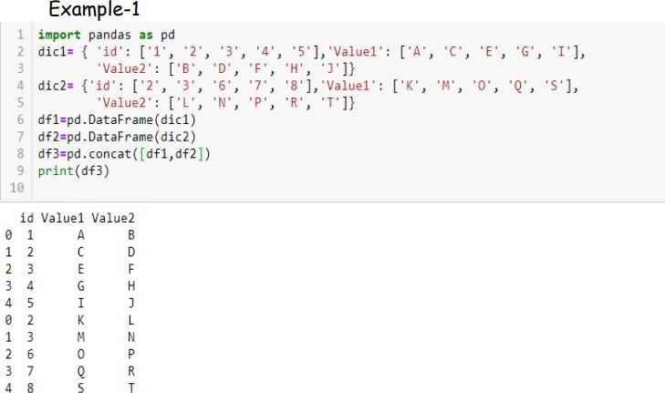

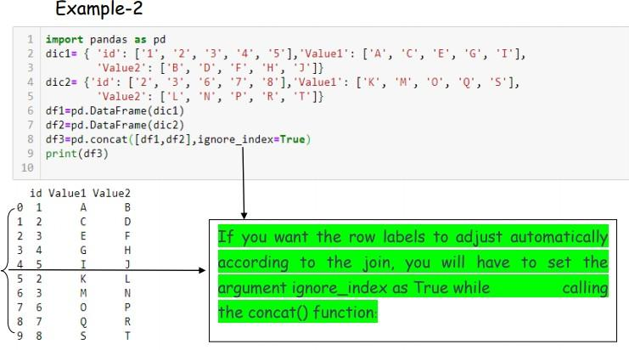

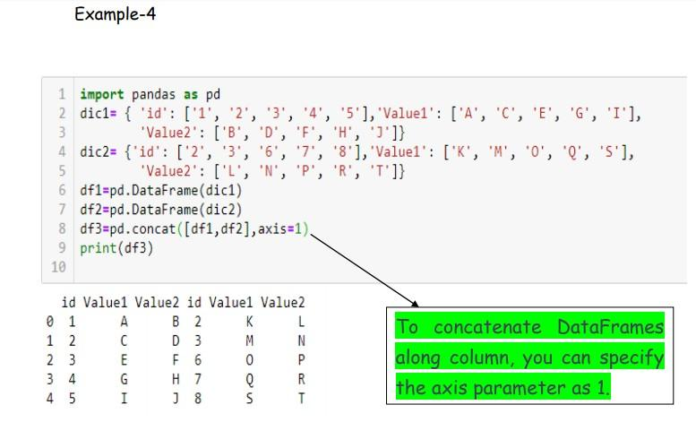

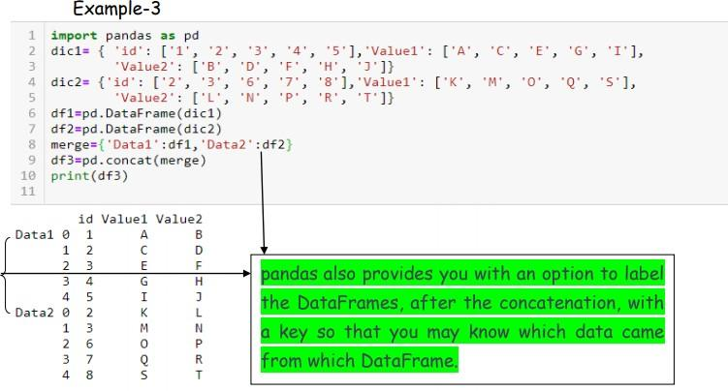

### Merge operation in data frame



Two DataFrames might hold different kinds of information about the same entity and linked by some common feature/column. To join these DataFrames, pandas provides multiple functions like merge(), join() etc.

Example-1

Example-2



### Join operation in data frame



It is used to merge data frames based on some common column/key.

1. **Full Outer Join**:- The full outer join combines the results of both the left and the right outer joins. The joined data frame will contain all records from both the data frames and fill in NaNs for missing matches on either side. You can perform a full outer join by specifying the how argument as outer in merge() function.

Example-



Example-2

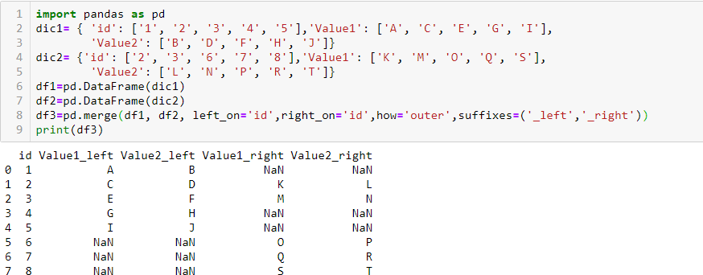

1. **Inner Join** :- The inner join produce only those records that match in both the data frame. You have to pass inner in how argument inside merge() function.

Example-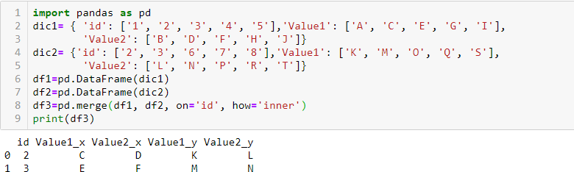

1. **RightJoin** :-The right join produce a complete set of records from data frame B(Right side Data Frame) with the matching records (where available) in data frame A( Left side data frame). If there is no match right side will contain null. You have to pass right in how argument inside merge() function.

Example-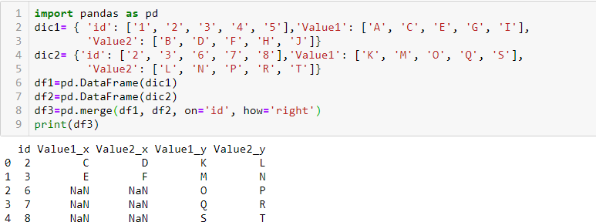

1. **Left Join** :- The left join produce a complete set of records from data frame A(Left side Data Frame) with the matching records (where available) in data frame B( Right side data frame). If there is no match left side will contain null. You have to pass left in how argument inside merge() function.

Example-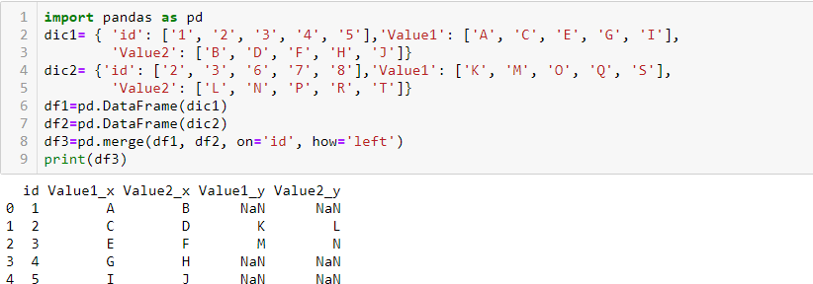

1. **Joining on Index** :-Sometimes you have to perform the join on the indexes or the row labels. For that you have to specify right_index( for the indexes of the right data frame ) and left_index( for the indexes of left data frame) as True.

Example-

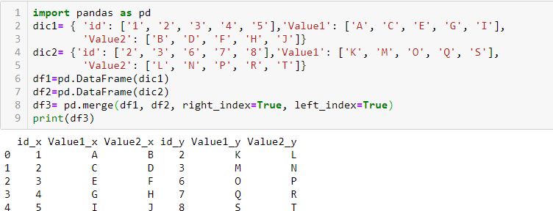

# CSV File



###### A CSV is a comma separated values file, which allows data to be saved in a tabular format. CSV is a simple file such as a spreadsheet or database. Files in the csv format can be imported and exported from programs that store data in tables, such as Microsoft excel or Open Office.

CSV files data fields are most often separated, or delimited by a comma. Here the data in each row are delimited by comma and individual rows are separated by newline.

###### To create a csv file, first choose your favorite text editor such as- Notepad and open a new file. Then enter the text data you want the file to contain, separating each value with a comma and each row with a new line. Save the file with the extension.csv. You can open the file using MS Excel or another spread sheet program. It will create the table of similar data.

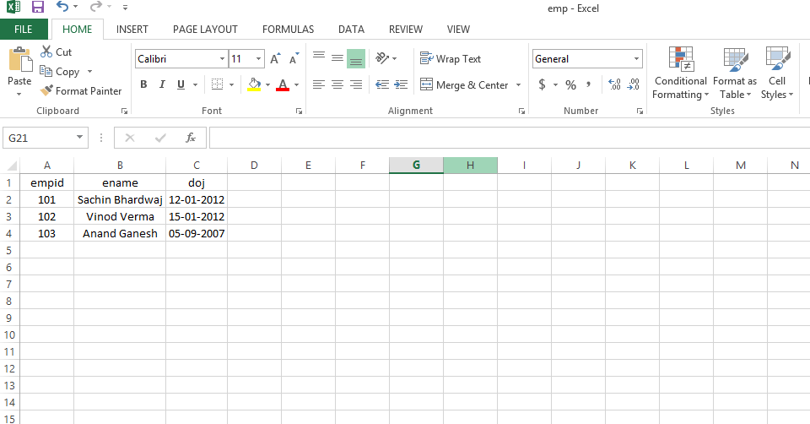

pd.read_csv() method is used to read a csv file.

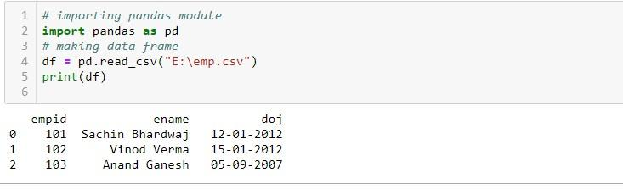

# Exporting data from dataframe to CSV File

###### To export a data frame into a csv file first of all, we create a data frame say df1 and use dataframe.to_csv(‘ E:\Dataframe1.csv ’ ) method to export data frame df1 into csv file Dataframe1.csv.

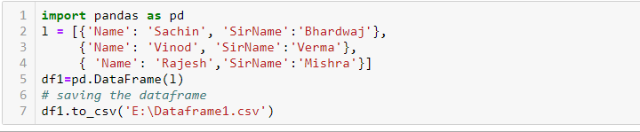

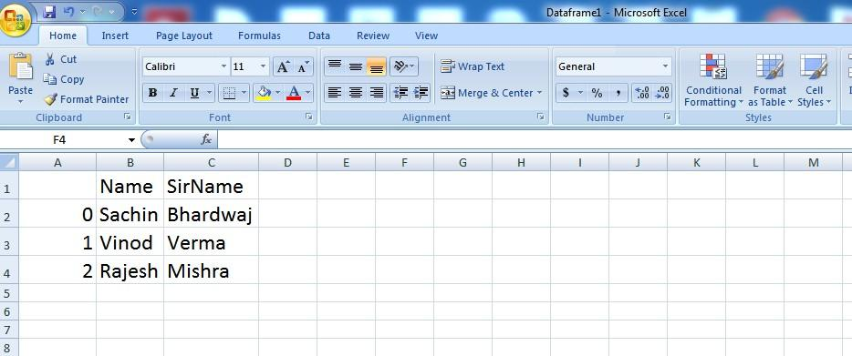

And now the content of df1 is exported to csv file Dataframe1.

**Data cleaning**

Data cleaning means fixing bad data in your data set.

Bad data could be:

* Empty cells
* Data in wrong format
* Wrong data
* Duplicates

## Empty Cells

Empty cells can potentially give you a wrong result when you analyze data.

import pandas as pd

df = pd.read_csv('data.csv')

new_df = df.dropna()

print(new_df.to_string())

#Notice in the result that some rows have been removed (row 18, 22 and 28).

#These rows had cells with empty values.

 By default, the dropna() method returns a *new* DataFrame, and will not change the original.

If you want to change the original DataFrame, use the inplace = True argument:

Remove all rows with NULL values:

import pandas as pd  
  
df = pd.read_csv('data.csv')  
  
df.dropna(inplace = True)  
  
print(df.to_string())

## Data of Wrong Format

Cells with data of wrong format can make it difficult, or even impossible, to analyze data.

To fix it, you have two options: remove the rows, or convert all cells in the columns into the same format.

convert all cells in the 'Date' column into dates.

import pandas as pd  
  
df = pd.read_csv('data.csv')  
  
df['Date'] = pd.to_datetime(df['Date'])  
  
print(df.to_string())

# Pandas - Fixing Wrong Data

import pandas as pd

df = pd.read_csv('data.csv')

df.loc[7,'Duration'] = 45

print(df.to_string ())